A000-PAC-Melan-Solomon Islands-New Georgia Island-Nguzu nguzu-Wood-Nautilus Shell-ca 19th c

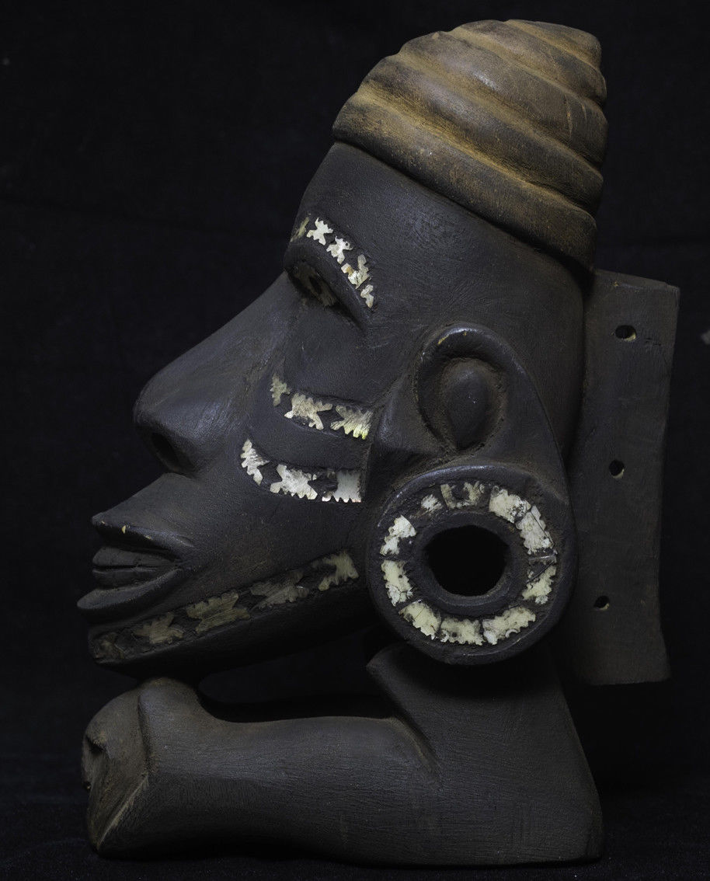

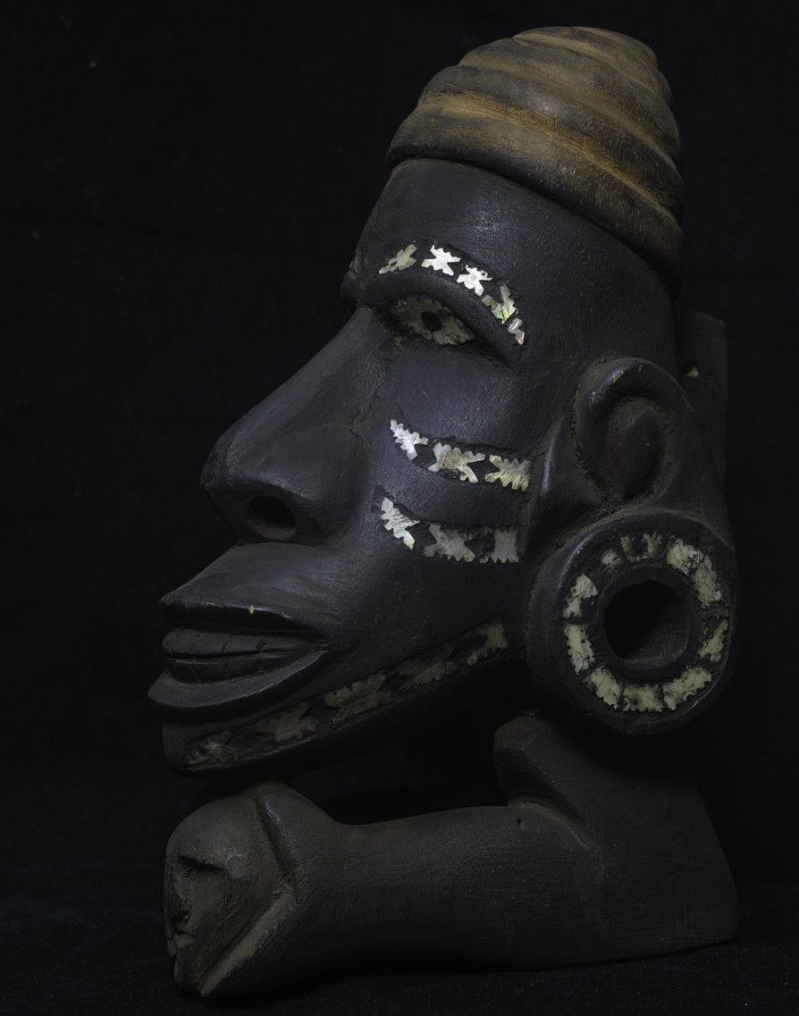 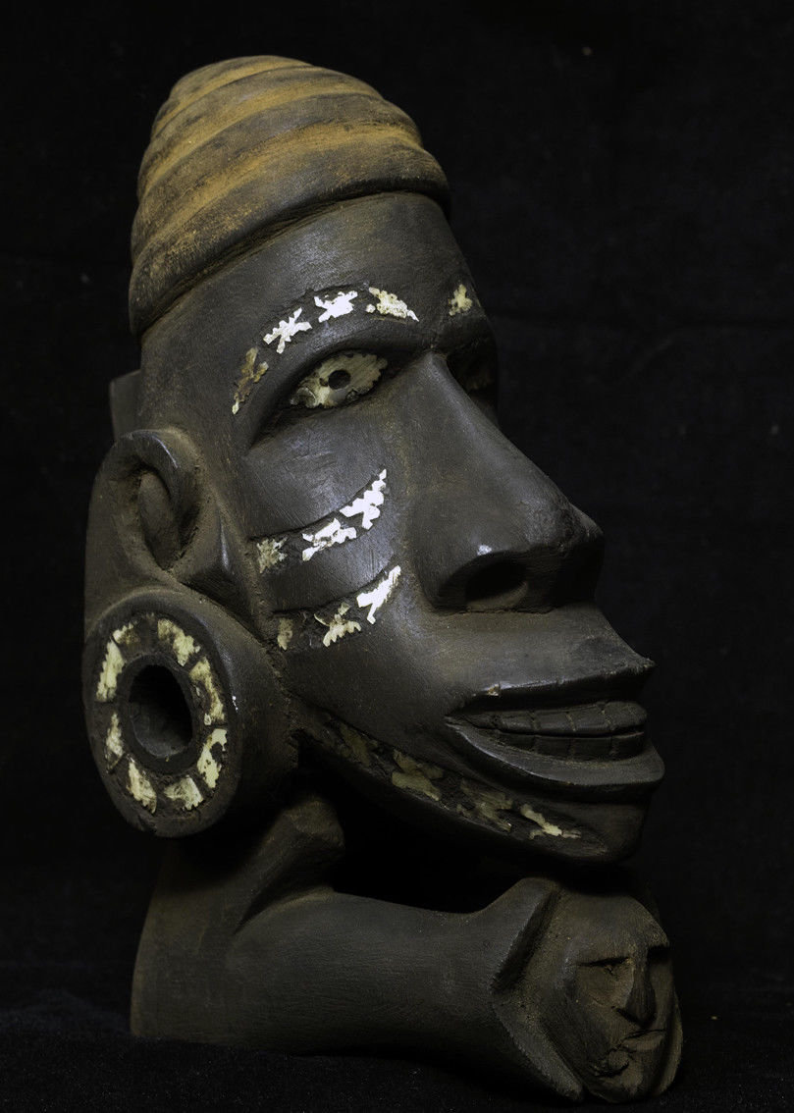 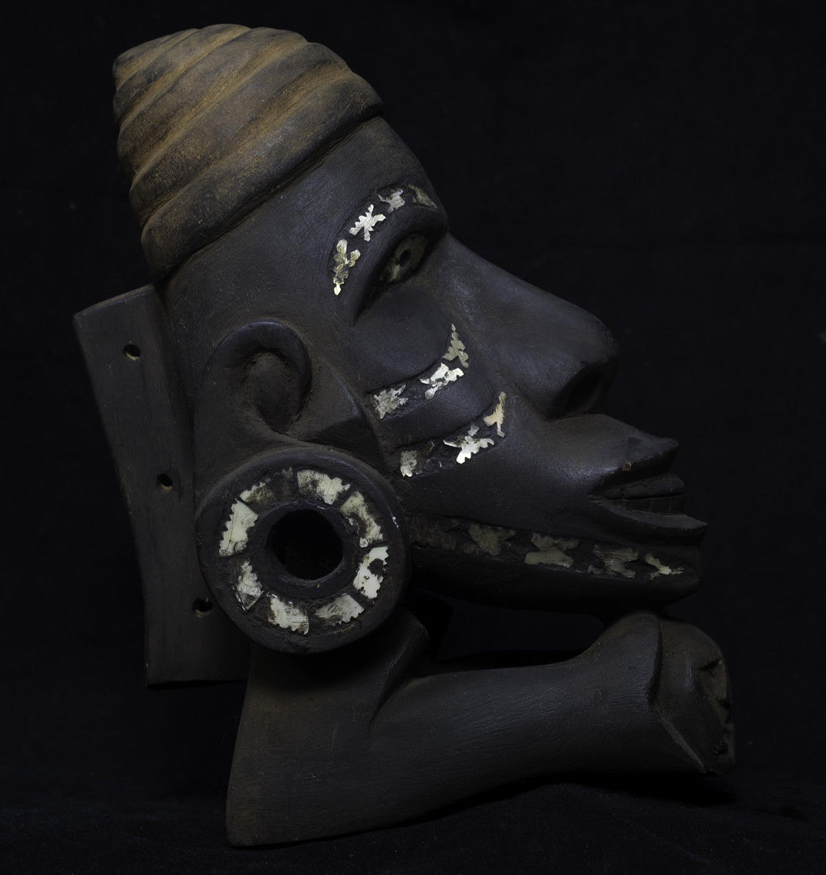

Roviana Lagoon-

Canoe figurehead (toto isu)

**black dye**

**Case No.: Oceania**

**Accession No.:**

**Formal Label:**

**Display Description:**

**Accession Number:**

**LC Classification:**

**Date or Time Horizon:**

**Geographical Area:**

**Map:**

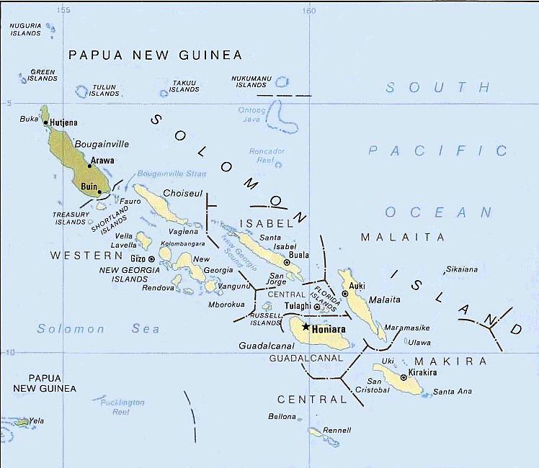

[**https://upload.wikimedia.org/wikipedia/commons/6/66/New_georgia_pol89.jpg**](https://upload.wikimedia.org/wikipedia/commons/6/66/New_georgia_pol89.jpg)

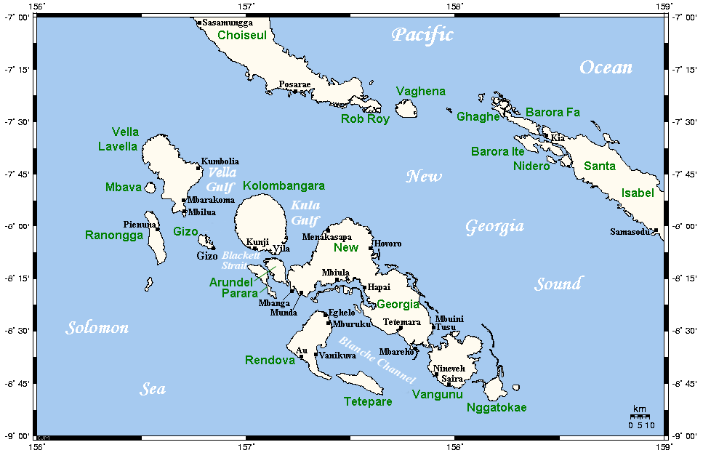 **https://upload.wikimedia.org/wikipedia/commons/1/1a/NewGeorgiaGroupCloseup.png**

**GPS coordinates:** [8°15′S 157°30′E](https://tools.wmflabs.org/geohack/geohack.php?pagename=New_Georgia&params=8_15_S_157_30_E_region:SB_type:isle)

**Cultural Affiliation:**

**Media:** wood, nautilus shell, black dye

**Dimensions:** 23 cm high

**Weight:**

**Condition: original**

**Provenance:** New Georgia Island, Roviana Lagoon

**Discussion:**

**References:**